

**NAME: SOFIA MUHAMMAD AAMIR**

**REGISTRATION NO: FA21-BSE-036**

**COURSE: WEB TECHNOLOGIES**

**ASSIGNMENT NO#01**

**SUBMITTED TO: SIR MUHAMMAD ALI KHAN**

**DATED: 6-APRIL-2023**

**COMSATS UNIVERSITY ISLAMABAD,**

**ABBOTTABAD CAMPUS**

**Home.html**

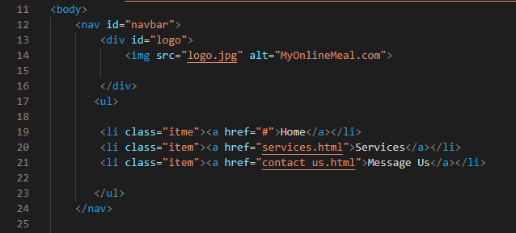

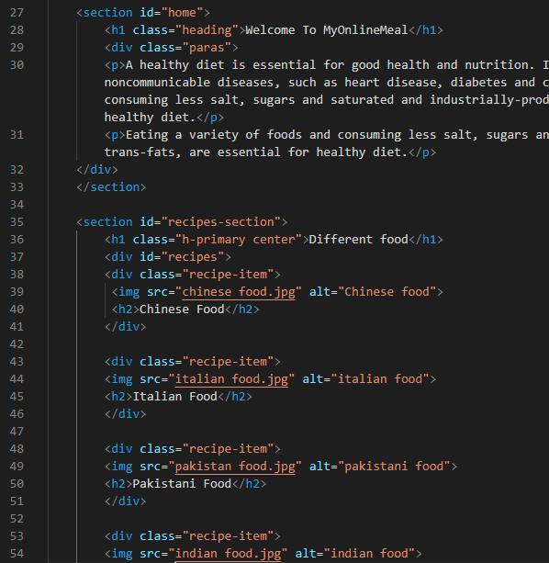

**Style.css**

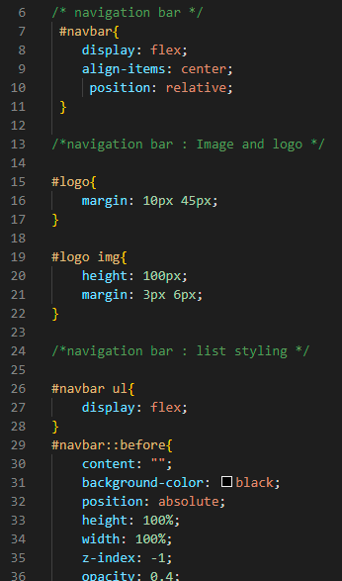

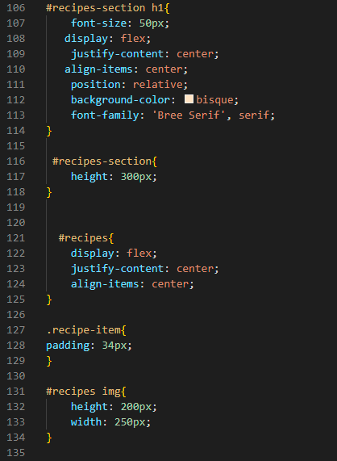



**Services.html**

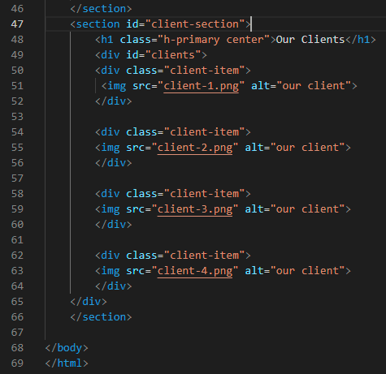

**Services.css**

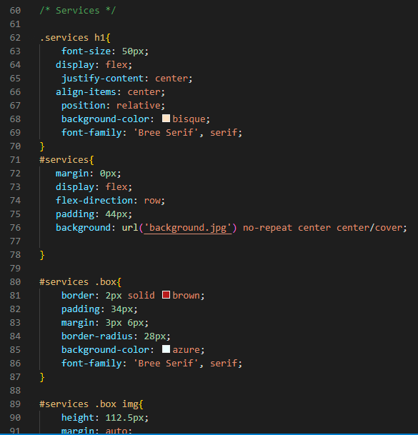

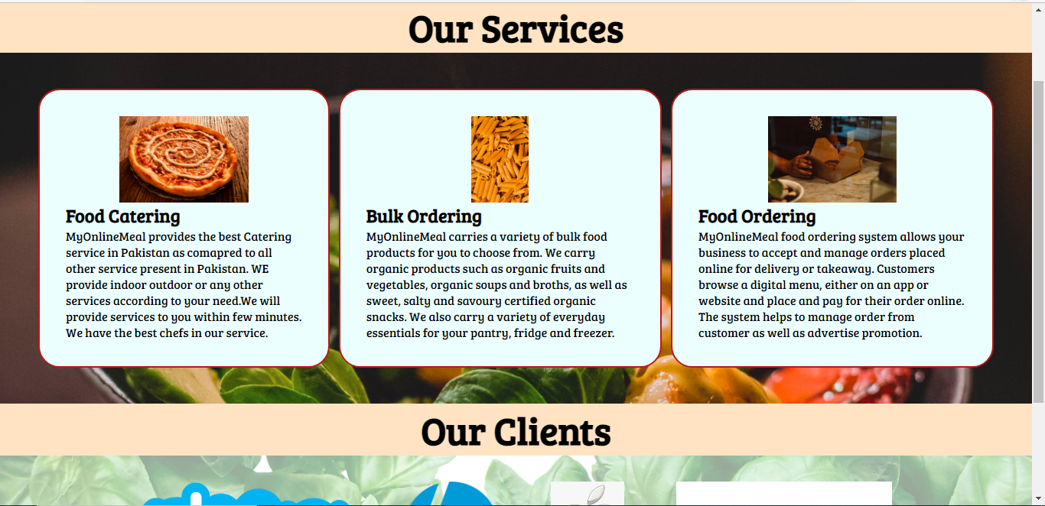

**Message us.html**

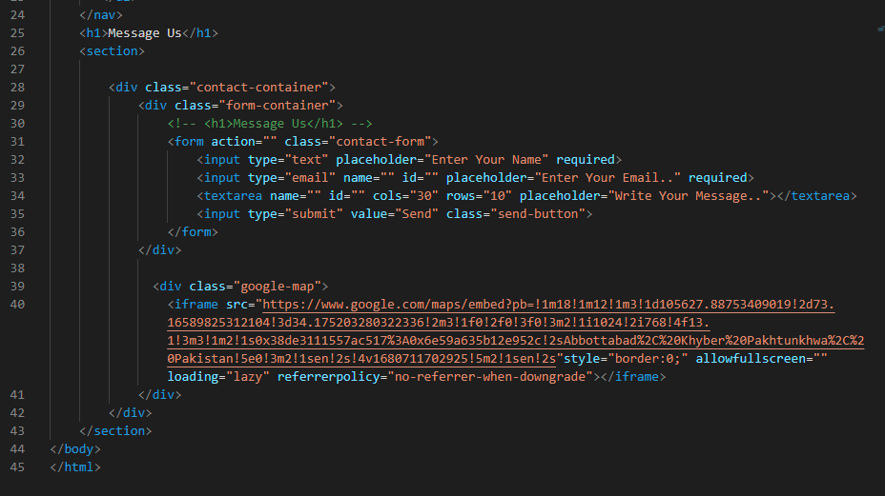

**Message us.css**

